Swachhta Pakhwada (15/10/2018 to 31/10/2018)
Swachhta Workshop: A workshop on the topics -Swachh Bharat Abhiyan , cleanliness , waste management , kitchen gardens , segregation of waste was organized on 26.10.2018 at the conference hall of CGST Commissionerate , Ludhiana. Shri. Maneet Dewan , Vice President of “Lets Clean Ludhiana” Foundation was invited as the lead speaker. Sh. Maneet Dewan is also an advisor to the Quality Council of India& has suggested various parameters for the audit of Swacchh Bharat Abhiyan.

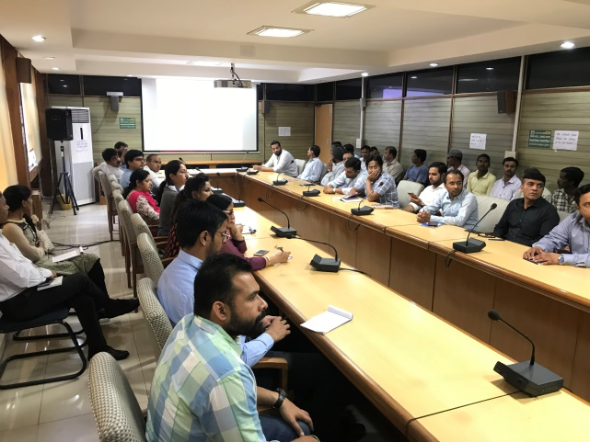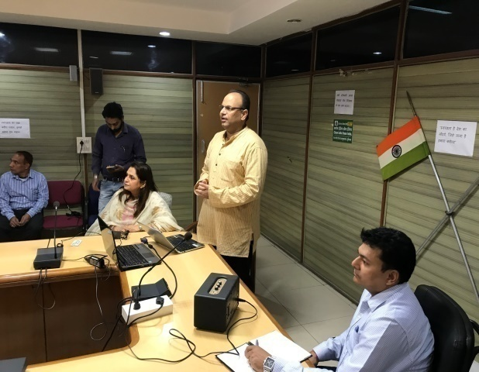
Pictures of the Swachhta Workshop held on 26.10.2018 at CGST Commissionerate ,Ludhiana

Distribution of Cloth /Jute Bags: Jute Bags were distributed to the officers/staff of GST Commissionerate Ludhiana & private citizens to encourage them to use cloth bags instead of polybags.
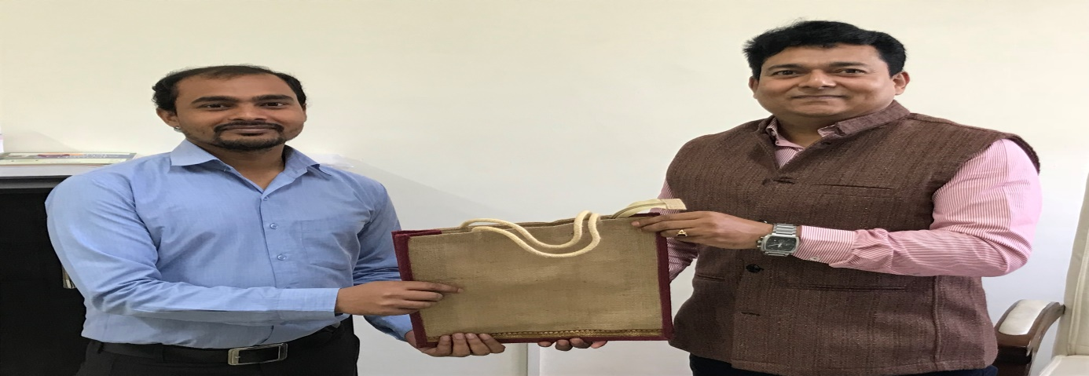

Jute Bags being distributed to the staff at GST Commisisonerate Ludhiana

